Attachment #1
[ENTRY FORM]
The 5thSaemangeum Cup International Yacht Race 2019
1. CLASS
- ORC |  |  |  | - OPEN |  |  |  |  |  | - J24/Sport
2. BOAT
Boat name: |  |  | Maker: |  |  |  |  | Model:
LOA: m |  |  | Beam: m |  |  |  |  | Draft(including keel): m
Sail Number: |  |  | Home Port: |  |  |  |  | Estimated arrive date:
3. SKIPPER
Name: |  |  | Address:
Nationality: |  |  | Sex: M / W |  |  |  | Contact Number:
Passport Number: |  |  |  |  |  |  | e-mail address:
Height: |  |  |  |  |  |  | Weight: |  |  |  | T-shirt size:
4. Crew List
NO | Name | Nationality |  |  | Passport | Contact |  |  | e-mail |  |  | Others
1 |  |  |  |  |  |  |  |  |  |  |  | Height(cm):  Weigh(kg): Sex:
2 |  |  |  |  |  |  |  |  |  |  |  | Height(cm):  Weigh(kg): Sex:
3 |  |  |  |  |  |  |  |  |  |  |  | Height(cm):  Weigh(kg): Sex:
4 |  |  |  |  |  |  |  |  |  |  |  | Height(cm):  Weigh(kg): Sex:
5 |  |  |  |  |  |  |  |  |  |  |  | Height(cm):  Weigh(kg): Sex:
6 |  |  |  |  |  |  |  |  |  |  |  | Height(cm):  Weigh(kg): Sex:
7 |  |  |  |  |  |  |  |  |  |  |  | Height(cm):  Weigh(kg): Sex:
8 |  |  |  |  |  |  |  |  |  |  |  | Height(cm):  Weigh(kg): Sex:
9 |  |  |  |  |  |  |  |  |  |  |  | Height(cm):  Weigh(kg): Sex:
10 |  |  |  |  |  |  |  |  |  |  |  | Height(cm):  Weigh(kg): Sex:
- Bank Account Details of the skipper(Remittance of prize money and boat travel support purposes)
Bank: |  |  |  |  |  | Account Number:
ABA Number: |  |  |  |  |  | SWIFT code:
Account Name:  (Beneficiary) |  |  |  |  |  | Other Information
Agreement: I agree to be bound by the ISAF Racing Rules of Sailing 2017-2020 (RRS), the ISAF Offshore Special Regulations 2018-2019, ORC Racing rules and the Notice of Race and Sailing Instructions for the race(s) concerned.
Skipper Name: |  |  |  |  | Signature: |  |  |  |  |  | Date:
Attachment #2
Account details and copy of passport
Copy of Account details
Copy of Passport

Attachment #3
Race Venue
▪coordinate:
35°37'05.6"N 126°27'49.3"E
(west breakwater)
Gyeokpo Harbor
Jeonlabuk-do, Saemangeum(Gyeokpo port, Saemangeum breakwater)
Event Hall Office

Mooring
Area
Gyeokpo Harbor
Race Office

Attachment #4
Racing Area and the Course
OFFSHORE:
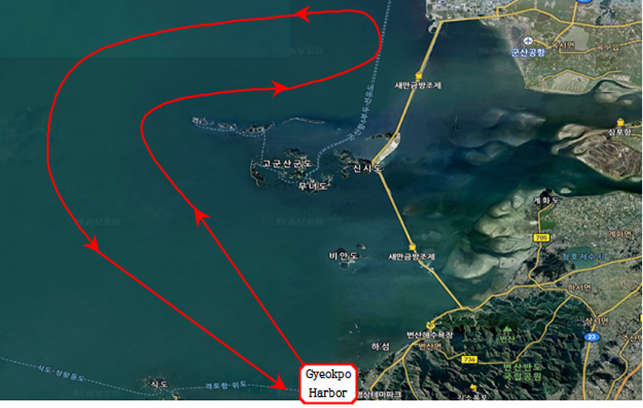

INSHORE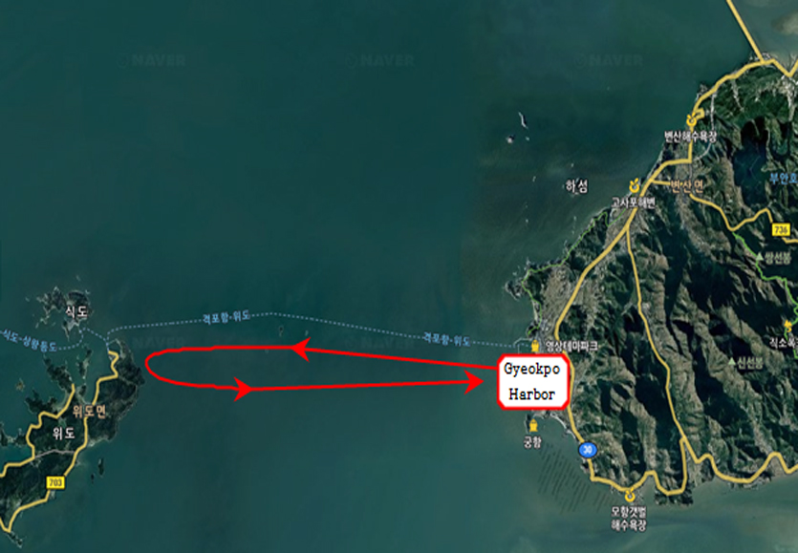

Coordinate of Major points
Jeonbuk, Gyeokpo Port  Venue for registration and race office  ▪Add:  Jeonbuk, Buan-gun, Gyeokpo-ri, Gyeokpoport, Korea  ▪coordinate:  35°37'05.6"N 126°27'49.3"E  (west breakwater) | Race OfficeOfficeOffice

Attachment #5
The 5thSaemangeum Cup International Yacht Race 2019
Written Oath

Name :
Passport Number :
Address:
Contact Number :

I am (Skipper or Boat owner) a representative of participating boats and crews who have applied for the "Saemangeum Cup International Yacht Race2019" In accordance World Sailing Racing Rule 4 "The responsibility for a boat’s decision to participate in a race or to continue racing is hers alone. In case of accidents involving civil or criminal accidents due to negligence or mismanagement of the crew or team members (crew) in participating in the "Saemangeum Cup International Yacht Race 2019" I will not objection to the Organizing Committee and Jeonbuk Sailing Federation .

2019. .

Skipper name :signature:
Boat owner name:signature:

