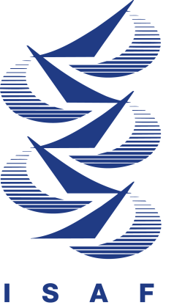 ISAF INTERNATIONAL JUDGING SEMINAR

Japan Sailing Federation

1. Member National Authority _______Japan Sailing Federation (JSAF)

2. Name of Co-ordinator(s) _ _Mr. Katsumi Shibanuma __

Direct telephone number(s) ___ +81 587 55 2806_ __ _

Direct fax number(s) ____+81 587 55 2806_______

E-mail number shiba_katsumi@ybb.ne.jp

- Dates of Seminar Official days: 10-12 February 2007,
Rules Clinic / Optional days: 8-9 February 2007
------------------------ See attached daily program

- Venue Hotel Twins Momochi (As same as the place of accommodation)

5. Attendance fee Official: 12,000JPY (App. 105US$)
(incl. 3 lunches, does not other meals and accommodation charges)
Rules Clinic / Optional: 3,000JPY (App. 25US$)
(does not include all meals and accommodation charges)

6. Accommodation:
Place ___Hotel Twins Momochi ______________
Address _ 1-7-4, Momochi-hama, Sawara-ku, Fukuoka-City, JAPAN___
Fukuoka International Airport – Nishijin St. (by Subway 20 minutes)
and Nishijin St. – Hotel (by Wake 15 minutes)
Website http://www.twinsmomochi.jp/
E-mail Address twm@fcc-web.com
Telephone Incl. country ___ __+81-92-852-4800____
Distance from Nearest Airport 10 Km from Fukuoka International Airport

Hotel charges Single room 7,100 JPY/night (include: breakfast, tax and service charge),
(Pleas make reservations at the co-ordinator, not directly at Hotel)

7. Final Registration Date ___22nd, January 2007___________

8. Number of attendees (maximum of 25): ________25________________

9. Application: Please fill in the Entry form and send to the co-ordinator.

