2009 Korea Cup International Yacht Race
17-25 May 2009, Pohang → Ulleungdo → Dokdo → Pohang, Korea

Notice of Race

1. | Rules
 | The Race will be governed by the Racing Rules of Sailing 2009-2012, ORC Club Rules, Korea Cup International Yacht Race Particular Rating System, and Sailing Instructions.
2. | Advertising
 | The race is designated as a Category C event in accordance with the ISAF Racing Rules of Sailing 2009 - 2012. All boats may be required to display the race sponsors' advertising on their boats.
3. | Eligibility and Entries
 | 3.1 | All boats shall be self-righting mono-hull keelboats over 9m in hull length.
 | 3.2 | Participating boats will be divided into the following classes
 |  | a) ORC Club - Boats with a valid 2009 ORC certificate
 |  | b) Open (PHRF)
 | 3.3 | All Korean sailors shall be a member of the Korea Sailing Federation (KSAF).
 | 3.4 | All Korean boats shall be a boat registered at the KSAF.
 | 3.5 | Entry
 |  | a) |  | Representative of each boat shall fill out the official entry form and submit it to the Organizing Committee by Wednesday on 15 April 2009.
 |  | b) |  | Late entries will be accepted by Wednesday 22 April 2009 with the additional payment of 100% of the entry fee. Entries after this date may be accepted at the discretion of the Organizing Authority.
 |  | c) |  | The following documents shall be submitted with the entry form  - Safety check list  - For a boat participating in the ORC class, a copy of the valid 2009 ORC Club Certificate
 |  | d) |  | Entry for the class over 20 entries may be closed in advance before the entry deadline.
 |  | e) |  | All boats shall register by 1700 hours Monday 18 May 2009 at the venue.
 | 3.6 | At least 4 crews including skipper shall be on board while racing for the purpose of safety.
4. | Entry fees
 | 4.1 | The following fees shall be paid to the account below at the time of submitting entry form :  50,000Won per boat plus 10,000Won per person  - Bank Name : Korea Exchange Bank  - Bank Address  903 Olympic Center, 88 Oryun-dong, Songpa-gu, Seoul, Korea  - SWIFT Code : KOEXKRSE  - Account No : 145-22-00669-7  - Account Name : Korea Sailing Federation
 | 4.2 | In case of no show, there is no refund of entry fees.
 | 4.3 | There is no entry fee for the invited boats.
5. | Schedule
Dates | Time | Programme
Sun. 17 May | 0900-1800 | • Registration / Measurement
Mon. 18 May | 0900-1800 | • Registration / Measurement
Tue. 19 May | 1000-1030 | • Skippers’ meeting
Tue. 19 May | 1100-1600 | • Pohang Inshore Race in Pohang Bukbu Beach
Tue. 19 May | 1800-2100 | • Opening Ceremony and Welcome party
Wed. 20 May | 0900-1000 | • Skippers’ meeting
Wed. 20 May | 1300 | • 1st Race start – Pohang to Ulleungdo  (130 mile / Time limit 24 hrs)
Thur. 21 May | 1300 | • 1st Race finish
Fri. 22 May | 1000-1100 | • Skippers’ meeting
Fri. 22 May | 1200-1600 | • Ulleungdo Inshore Race
Fri. 22 May | 1900-2100 | • Welcome party in Ulleungdo
Sat. 23 May |  | • Spare Day
Sun. 24 May | 0000 | • Start for the parade  ; Ulleungdo to Dokdo (47.2 mile)
Sun. 24 May | 1000 | • 2nd Race start  ; Dokdo to Pohang  (135 mile / Time limit 30 hrs)
Mon. 25 May | 1600 | • 2nd race finish
Mon. 25 May | 2000-2200 | • Closing & Awarding Ceremony  in Pohang

6. | Measurement and Inspection
 | The official measurer may require any boats to be inspected and measured for the purposes of safety.
7. | Sailing Instructions
 | Sailing Instructions will be available at registration from 17 May 2009.
8. | Venue
 | Attachment 1 shows the location of the race harbor and the racing areas.
9. | The Courses
 | The courses to be sailed will be available at the SI.
10. | Penalty system
 | 10.1 |  | RRS 44.1 and 44.2 will apply
 | 10.2 |  | Decisions of the International Jury will be final as provided in RRS 70.5
11. | Scoring
 | 11.1 |  | RRS Appendix A 3 will apply.
 | 11.2 |  | ORC Club rules and Korea Cup International Yacht Race particular rating system will apply.
 | 11.3 |  | Completion of one of the two races(Legs) is required to be completed to constitute Korea Cup International Yacht Race and 1 race is required to be completed to constitute the Pohang Inshore Race and the Ulleungdo Inshore Race.
12. | Support Boats
 | Official support boats shall display the flags designated by the Organizing Authority.
13. | Berthing
 | boats shall be kept in their assigned places in the harbor.
14. | Haul-Out Restrictions
 | Boats shall not be hauled out during the Race except with and according to the terms of prior written permission of the Organizing Authority.
15. | Diving Equipment and Plastic Pools
 | Underwater breating apparatus and plastic pools or their equivalent shall not be used around boats between the preparatory signal of the first race and the end of the Race.
16. | Radio Communication
 | The radio system (Marine VHF) shall be on while racing and it will be mandatory for boats to carry portable GPS in case it is supplied by the Organizing Authority.
17. | Prizes
 | 17.1 |  | The boat that crosses the finish line of each Leg regardless of the classes and hanicap will be given "the first finish prize"
 | 17.2 |  | Prizes will be given as follows:
• First Finish
- 1st Leg : Diploma, Trophy, 1,000,000Won
- 2nd Leg : Diploma, Trophy, 1,000,000Won
• ORC Club (Each Leg)
- 1st : Diploma, Trophy, 4,000,000Won
- 2nd : Diploma, Trophy, 2,500,000Won
- 3rd : Diploma, Trophy, 2,000,000Won
- 4th : Diploma, Trophy, 1,000,000Won
- 5th : Diploma, Trophy, 500,000Won
• OPEN (Each Leg)
- 1st : Diploma, Trophy, 2,500,000Won
- 2nd : Diploma, Trophy, 2,000,000Won
- 3rd : Diploma, Trophy, 1,500,000Won
- 4th : Diploma, Trophy, 1,000,000Won
- 5th : Diploma, Trophy, 500,000Won
18. | Safety
 | The safety of a boat and her entire management shall be the sole responsibility of the owner/skipper. The ISAF Offshore Special Regulations Category 3 will apply. Every owner/skipper shall warrant the stability of his/her boat for the race.
19. | Disclaimer of Liability
 | Competitors participate in the Race entirely at their own risk. See rule 4, Decision to Race. The organizing authority will not accept any liability for the material damage or personal injury or death sustained in conjuction with or prior to, during, or after the Race.
20. | Subsidy
 | 20.1 |  | 1,000,000~5,000,000Won will be given to each boat according to the distance from her home port to the venue and the number of crew. Boats that finish the 1st Leg only will be given 30% of the subsidy. But, the Organizing Authority may give some or whole of the subsidy if they recognize that the failure to complete the 1st or 2nd Leg was inevitable.
 | 20.2 |  | The above subsidy will not be given to the invited teams. Instead, the invited teams will be given flight, charter boat, accommodation, and meals during their stay for the race by the Organizing Authority.
21. | Organizing Authority
Korea Sailing Federation
903 Olympic Center, 88 Oryun-dong, Songpa-gu, Seoul, KOREA
Tel. +82 2 420 4392, Fax. +82 2 420 4391
www.kasf.org
koct@naver.com

Attachment
- Race Course
- Entry Form
- Offshore Special Regulation Category 3 Check List

1. Race Course

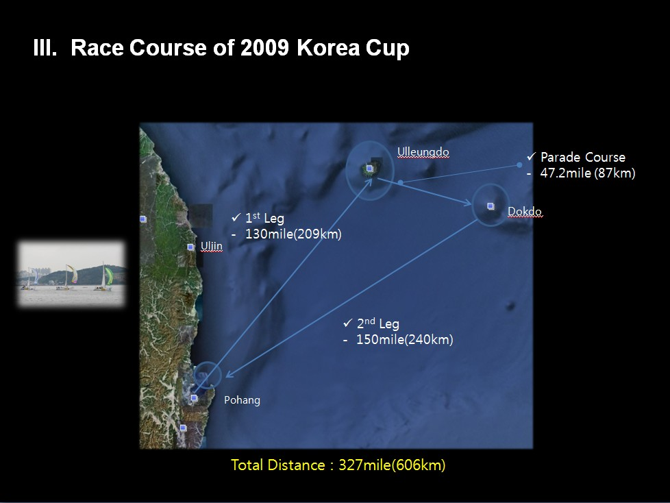

2. Entry Form

Please submit this form together with a copy of your entry payment, 2009 ORC Certificate, and safety check list to the organizing authority.

2009 Korea Cup International Yacht Race Entry Form
Description of Boat
Boat Name |  |  |  |  |  |  |  |  |  |  |  |  |  |  |  |  | Builder Name |  |  |  |  |  |  |  |  |  |  |  |  |  |  | Model No.
Class (tick where applicable) |  |  |  |  |  |  |  |  |  |  |  |  |  | ORC Club ( ), Open ( ) |  |  |  |  |  |  |  |  |  |  |  |  |  |  |  |  | Sail No
Home Port |  |  |  |  |  |  |  |  |  |  |  |  | Hull Length |  |  |  |  |  |  |  |  |  |  |  |  | Beam |  |  |  |  |  |  | Draft |  |  |  |  |  |  |  | Weight
Estimated Arrival Date |  |  |  |  |  |  |  |  |  | Estimated Departure Date |  |  |  |  |  |  |  |  |  |  |  |  |  |  |  |  | Port to leave for after the race
Skipper
Name |  |  |  | Sex |  |  | Height  (Cm) |  |  |  | Weight  (Kg) |  |  |  |  | Passport No. |  |  |  |  | Date of Birth |  |  |  |  |  |  |  | Address |  |  |  |  |  | Email |  |  |  |  |  |  | Mobile Phone
Major Sailing Careers
Crews
No. | Name |  |  |  | Sex |  |  | Height  (Cm) |  |  |  | Weight  (Kg) |  |  |  |  |  | Passport No. |  |  |  |  | Date of Birth |  |  |  |  | Address |  |  |  |  |  |  |  |  |  | Email |  |  |  |  | Mobile Phone
1
2
3
4
5
6
7
8
9
10
Account details to receive subsidy and prize money
Bank Name |  |  |  |  |  |  |  |  | Bank Address |  |  |  |  |  |  |  |  |  |  |  |  | Account No. |  |  |  |  |  |  |  |  |  |  |  | Beneficiary Name
Declaration by Skipper
I agree to be bounded by the ISAF Racing Rules of Sailing 2009- 2012RRS), ORC Club, Korea Cup International Yacht Race Particular Rating System, and Sailing Instructions.
Skipper's Name |  |  |  |  |  |  |  |  |  |  |  |  |  |  |  |  |  |  | Date |  |  |  |  |  |  |  |  |  |  |  |  | Signature
Contact
Mr. Jungho Yoon, Korea Sailing Federation
903 Olympic Center, 88 Oryun-dong, Songpa-gu, Seoul, KOREA
Tel. +82 2 420 4392, Fax. +82 2 420 4391
www.kasf.org; koct2000@naver.com

3. Offshore Special Regulation Category 3 Check List

1. This list is to check the ship owners themselves and some parts of yacht equipment, and it does not cover all of the OSR.
2. The race committee checks only if there are the equipments required, it does not guarantee the safety of the yachts..
3. Yacht owners are required to tick the box of each clause and keep the original one in their boats. A copy is to be presented to the race committee at registration.

The name of boat :
1.02.1 | Does the boat owner understand the basic rules and definitions of the OSR section 1? | □
2.03.3 | When to show navigation lights  a) Navigation lights (OSR 3.27) shall be shown as required by the International Regulations for Preventing Collision at Sea, (Part C and Technical Annex 1). All yachts shall exhibit sidelights and a stern light at the required times. | □
3.27 | Navigation Lights (see OSR 2.03.3) | □
3.27.1 | Navigation lights shall be mounted so that they will not be masked by sails or the heeling of the yacht
3.27.2 | Navigation lights shall not be mounted below deck level and should be at no less height than immediately under the upper lifeline.
3.27.3 | Navigation light intensity
  LOA | Required minimum power rating for an electric bulb in a navigation light
  Under 12m | 10W
  12m and above | 25W
3.27.4 | Reserve navigation lights shall be carried having the same minimum specifications as the navigation lights above, with a separable power source, and wiring or supply system essentially separate from that used for the normal navigation lights.
3.27.5 | Spare bulbs for navigation lights shall be carried, or for lights not dependent on bulbs, appropriate spares.
3.28.3 b | A propulsion engine required by Special Regulations shall:  b) have a minimum amount of fuel which may be specified in the Notice of Race but if not, shall be sufficient to be able to meet charging requirements for the duration of the race and to motor at the above minimum speed for at least 8 hours. | □
3.28.3 d | When an electric starter is the only method for starting the engine, have a separate battery, the primary purpose of which is to start the engine. | □
4.04 | Jackstays, Clipping Points and Static Safety Lines
4.04.1 | The following shall be provided:  a) Jackstays shall be provided-  ⅰ) attached to through-bolted or welded deck plates or other suitable and strong anchorage fitted on deck, port and starboard of the yacht’s centre line to provide secure attachments for safety. | □
4.04.2 | Clipping Points:  Shall be provided-  a) attached to through-bolted or welded deck plates or other suitable and strong anchorage points adjacent to stations such as the helm, sheet winches and masts, wher e crew members work for long periods:  b) which, together with jackstays and static safety lines shall enable a crew member  ⅰ) to clip on before coming on deck and unclip after going below;  ⅱ) whist continuously clipped on, to move readily between the working areas on deck and cockpit(s) with the minimum of clipping and unclipping operations.  c) The provision of clipping points shall enable two-thirds of the crew to be simultaneously clipped on without depending on jackstays. | □
4.05.1 | Fire extinguishers, at least two, readily accessible in suitable and different parts of the yacht. | □
4.08 | A suitable Fist Aid Manual shall be provided. | □
4.09 | A foghorn shall be provided. | □
4.10.1 | A passive Radar Reflector (that is, a Radar Reflector without any power) shall be provided. | □
4.16 | Tools and spare parts, including effective means to quickly disconnect or sever the standing rigging from the hull shall be provided. | □
4.17 | Yacht’s name shall be on miscellaneous buoyant equipment, such as lifejackets, cushions, lifebuoys, life slings, grab bags etc. | □
4.22.1 a | The following shall be provided within reach of the helmsman and ready for instant use:  a) a lifebuoy with a self-igniting light and a drogue or a Life sling with a self-igniting light and without a drogue. | □
4.23.1 | - 2 red parachute flares shall be on board.  - 2 red hand flares shall be on board.  - Orange smoke shall be on board. | □
4.23.2 a | The following lights shall be provided and readily available for the purpose of collision avoidance:  a) a watertight white torch (flashlight) with spare batteries and bulb. | □
5.01 | Each crew member shall have a lifejacket as follows:  a) Equipped with a whistle.  b) fitted with marine grade retro-reflective material (OSR 4.18)  c) Compatible with the wearer’s safety harness.  d) If inflatable, regularly checked for air retention.  e) Clearly marked with the yacht’s or wearer’s name. | □
5.02 | Each crew member shall have a harness and safety line that complies with EN 1095 (ISO12401) or equivalent with a safety line no more than 2m in length.  a) Warning it is possible for a plain snap hook to disengage from a U-bolt if the hook is rotated under load at right-angles to the axis of the U-bolt. For this reason the use of snap hooks with positive locking devices is strongly recommended. | □

, 2009

The name of owner :
Signature :

